Lab Activity #5
Advance Networking 313
Name |  |  |  | Score | /100
Course, Year & Section |  | Date |  | Score | /100

- Introduction to Packet Tracer
- Identifying Local Area Network Components
- Simulate a Local Area Network

Introduction to Packet Tracer:
Exercise 1: Creating a Simple Home/Office Local Area Network using Packet Tracer.
Step 1: Click on the Device-Type box and select Wireless devices, next on the Device-Specific box select WRT300N device and drag it on the workspace.
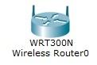
Step 2: Click on the Device-Type box and select Switches, next on the Device-Specific box select 2960 device and drag it on the workspace.
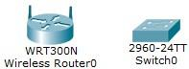

Step 3: Click on the Device-Type box and select End-Devices, next on the Device-Specific box select Generic Laptop or a Desktop device and drag it on the workspace.
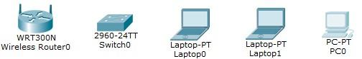

Step 4: Now let us cable our devices, Let’s review our cables. What cable should we use if we are connecting a pc to a switch? Just a tip, remember when you are connecting “Unlike Devices”? Pc to a switch is unlike devices, therefore we should use _____________________________ cable.
On the Device-Type box click on the Connections icon , on the Device-Specific box look for the cable to use and select by clicking  (Copper Straight-Through) or  (Copper Cross-Over).
Connecting a Pc to a Switch:
Once the cable has been selected click on the laptop and select FastEthernet0, on the Switch select the FastEthernet0/1 or any other port available. (note: no of switchports depends on the model you use). Do the same with the other end-devices. :
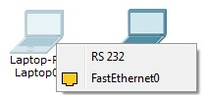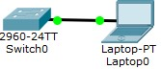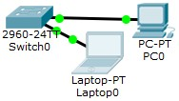

Connecting Router (SOHO) to a Switch:
Next, lets connect the Router to the Switch. Note that currently the router we are using is a SOHO router that has a built in 4 port switches at the back, we are going to connect the switch to another switch port of the SOHO router. That seems to be a “Like Device”, remember how do we connect “Like Device”? We use the _____________________________ cable.
Note: “Auto MDI-X ports on newer network interfaces detect if the connection would require a crossover, and automatically chooses the MDI or MDI-X configuration to properly match the other end of the link.” .
Auto MDI-X is the reason why mostly, we use Straight Through cable on our networks. Source: https://en.wikipedia.org/wiki/Medium-dependent_interface

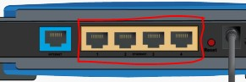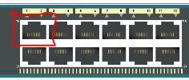

Click on the Switch and click on a available port on the Switch, (example: FastEthernet0/24). After the cable has been plugged in to the switch, connect it now to the router. Click on the router and click on any of the ETHERNET ports (Ethernet 1 - 4). Our diagram now should look like the one below:

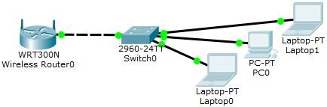

Now our network is connected and ready, let us now setup the TCP/IP settings. Let us start with the configuration of our router.
Setting up Router:
Click on the Router (WRT300N), on the tab click on GUI (Graphical User Interface).
On the Start IP Address make sure to change the 4th octet to 2, this will make the router to start giving ip address starting from 192.168.0.2 – 254 (depending on your maximum no of users).
Make sure that DHCP Server is enabled, our router is setup to be the DHCP server and will give out Network parameters to our clients. (IP address, Subnet Mask, Default Gateway, etc.) Make sure to click on Save Settings for changes to retain.
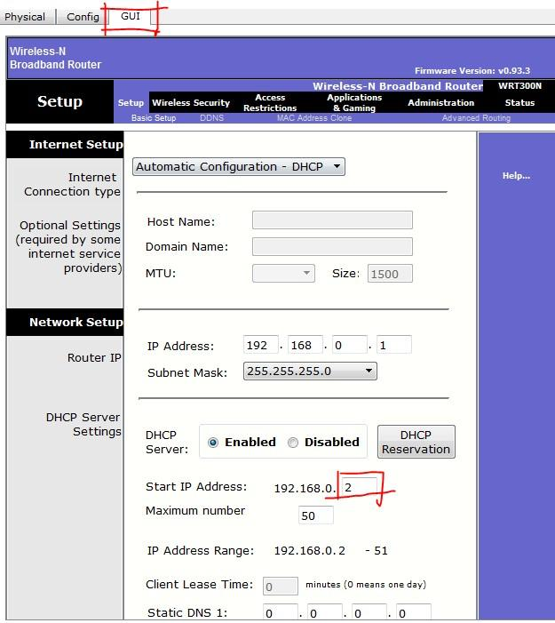

Setting up the Clients:
Now, our router is now ready to give out network parameters. Let us now start configuring our clients (Laptops and Desktops etc.). Click on the first Laptop and click on the Desktop tab. Next click on the IP Configuration icon.

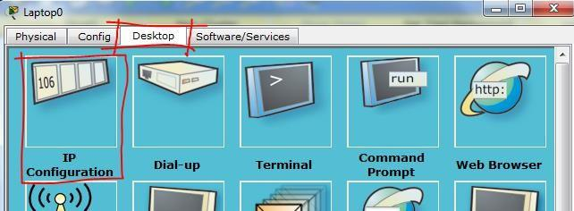

Next, by default our clients our set to Static. Next click on the DHCP button:

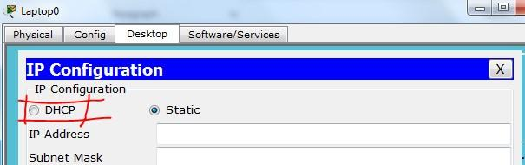

Notice that we have now acquire our network parameters:
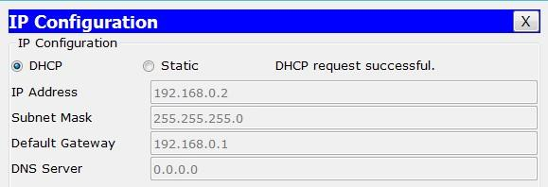
Now do the same with the 2nd clients.

Setting up a Static Network parameter to a client:
On our 3rd client we will be doing the static ip addressing, we will setup the parameters manually. Type in the information on below screenshot:
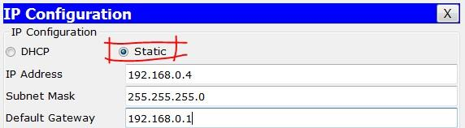
Now let us test the connectivity of our network using some of the TCP / IP tools.:
Click on the first Laptop > next click on Desktop > next click on Command Prompt:
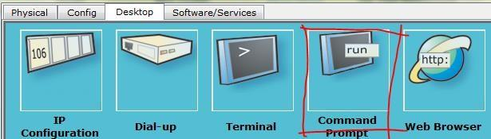

The Command Prompt will now display, this command prompt behaves like the command prompt on your typical Microsoft windows OS.
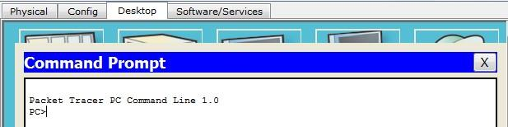

Most commonly used TCP / IP windows tools:
Utility | Used to
Ping | Send ICMP Echo Requests to verify that TCP/IP is configured correctly and that a remote TCP/IP system is available.
Ipconfig | Display current TCP/IP network configuration values, and update or release Dynamic  Host Configuration Protocol (DHCP) allocated leases, and display, register, or flush Domain Name System (DNS) names.
Tracert | Trace a path to a remote system.
Netstat | Display statistics for current TCP/IP connections.

The first command is to test the connectivity using the PING command.
Type Ping 192.168.0.2 / 3 . this will test our connectivity from pc 1 to pc 2 to pc 3 (Static)
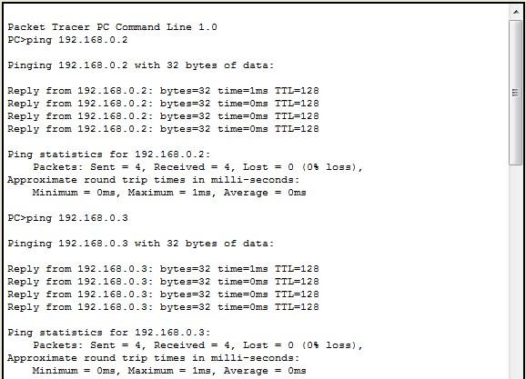
Notice the Reply from 192.168.0.2 (3) bytes=32 time 1ms TTL-128, this indicates that we have a connection to all clients. Our network is working correctly.
Next Tool, the IPCONFIG /ALL command:
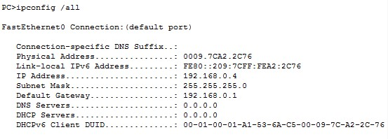

Ipconfig command, displays all configuration information including the Mac address of the NIC card. You can also try ipconfig /release, this will release (removed) the ip address. Next Ipconfig /renew, this command will renew the ip address of the computer.

